

Practices for Secure Software Report

Table of Contents
Document Revision History 3
Client 3
Instructions 3
Developer 4
1. Algorithm Cipher 4
2. Certificate Generation 4
3. Deploy Cipher 4
4. Secure Communications 4
5. Secondary Testing 4
6. Functional Testing 4
7. Summary 4
8. Industry Standard Best Practices 4

Document Revision History

Version | Date | Author | Comments
1.0 | 26 October 17 | Richard Clark

Client



Instructions

Submit this completed practices for secure software report. Replace the bracketed text with the relevant information. You must document your process for writing secure communications and refactoring code that complies with software security testing protocols.

- Respond to the steps outlined below and include your findings.
- Respond using your own words. You may also choose to include images or supporting materials. If you include them, make certain to insert them in all the relevant locations in the document.
- Refer to the Project Two Guidelines and Rubric for more detailed instructions about each section of the template.

Developer
Richard Clark

Algorithm Cipher

AES-256 as the encryption cipher and SHA-256 as the hashing algorithm would provide the best appropriate encryption algorithm cipher for Artemis Financial. AES-256 is an industry-standard symmetric encryption cipher that protects sensitive financial data by converting readable information into ciphertext that can only be decrypted with the correct key. It operates on 128-bit data blocks and uses a 256-bit key, providing strong confidentiality during storage and transmission. To complement this, SHA-256 serves as the hashing algorithm, producing a fixed 256-bit digest regardless of input size. SHA-256 is designed to be collision-resistant, meaning it is computationally infeasible for two different inputs to generate the same hash value. This bit-level strength ensures that any modification to the data results in a completely different hash, allowing Artemis Financial to reliably detect tampering. AES 256 and SHA 256 form a layered security approach in which AES keeps the data private, while SHA 256 ensures its integrity.
Secure cryptographic operations, like AES, depend heavily on high-quality random numbers. Computers gather randomness from unpredictable hardware events, but this supply is limited. Java uses a special generator called a CPRNG, which creates random-looking numbers based on a good initial seed. The SecureRandom class provides these values, but it needs to be seeded correctly and refreshed from time to time to stay secure. If the random numbers are predictable or poorly generated, the whole encryption process becomes weaker which makes strong randomness a must requirement for safe cryptographic operations (Manico & Detlefsen, 2014).
AES is a symmetric encryption cipher because it uses the same secret key for both encryption and decryption. In contrast, asymmetric algorithms like RSA use a key pair consisting of a public key and a private key. The public key is used for encrypting or verifying, while the private key is used for decrypting or signing. Unlike symmetric algorithms such as AES, RSA is not designed for encrypting large amounts of data (Manico & Detlefsen, 2014). As Manico and Detlefsen (2014) describe, RSA is primarily used for signatures, key exchange, and certificate validation, meaning it serves a different role in secure systems. Symmetric algorithms such as AES are far better suited for tasks like encrypting archive files, securing stored data, and protecting data transfers.
Manico and Detlefsen (2014) shows a clear shift in the field of cryptography. Older algorithms that were once widely used have become unsafe, and modern, vetted algorithms now form the foundation of secure systems. Legacy algorithms such as DES, 3DES, RC4, MD5, and SHA-1 are no longer considered secure because advances in computing power and cryptanalysis have exposed weaknesses that make them vulnerable to attacks. Modern algorithms like AES and RSA represent the current state of secure cryptography. AES is highlighted as the recommended symmetric cipher due to its strong key sizes and its ability to replace outdated options like DES and 3DES. RSA is described as the most widely used public-key algorithm, primarily for signatures, key exchange, and certificate validation.

Certificate Generation
Insert a screenshot below of the CER file.

A 2048-bit RSA key pair and self-signed certificate were generated using the Java Keytool utility with the SHA384withRSA signature algorithm. The certificate was exported as a .cer file and keystore.jks were stored. The output confirms the certificate’s owner, issuer, validity dates, fingerprints (SHA-1 and SHA-256), and key algorithm. The screenshot below demonstrates successful certificate creation and validation.

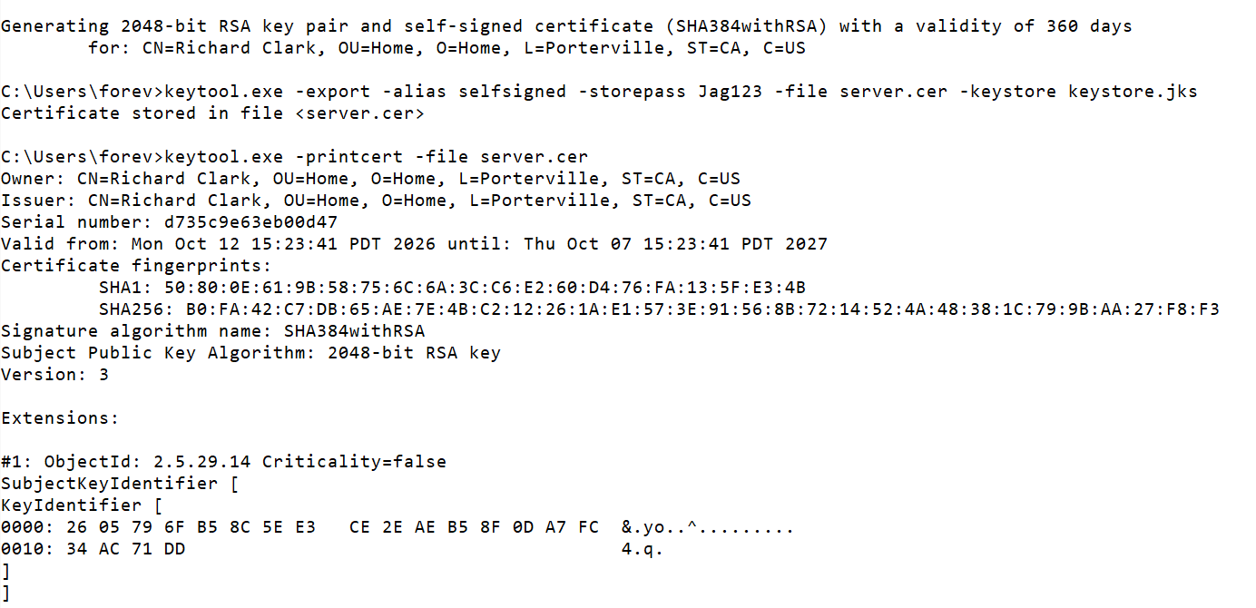

Deploy Cipher
Insert a screenshot below of the checksum verification.

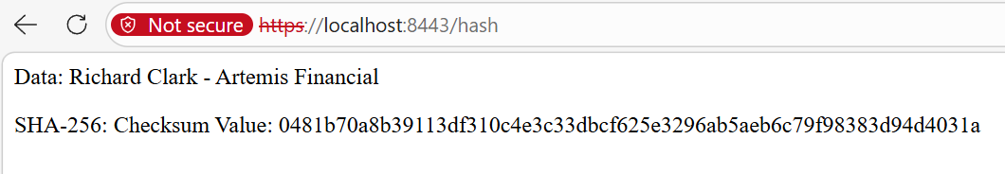

Secure Communications
Insert a screenshot below of the web browser that shows a secure webpage.

The application was refactored to enable secure communication using the HTTPS protocol. The application.properties file was updated to configure SSL with a self-signed certificate stored in a Java keystore. The server was then compiled and launched on port 8443.

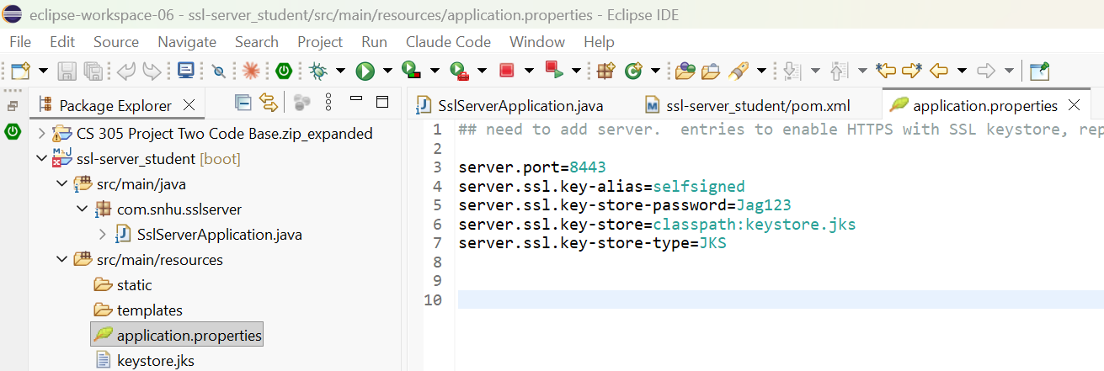

Secondary Testing
Insert screenshots below of the refactored code executed without errors and the dependency-check report.

After refactoring the code to implement secure communication, a secondary static analysis was performed using the OWASP Dependency-Check tool to verify compliance with software security enhancements. The refactored application executed successfully, as shown in Screenshot A, where the Spring Boot server starts on HTTPS port 8443 without errors.
Screenshot B displays the Dependency-Check report output, which scanned 49 dependencies and identified 14 vulnerable components. The results confirm that no new vulnerabilities were introduced by the refactoring. Existing findings relate to third-party libraries such as Jackson, Log4j, and Spring Core, which are known issues documented in the OWASP database.
A)
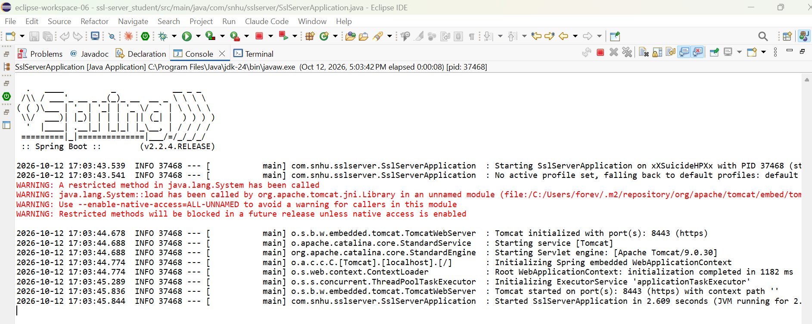

B)
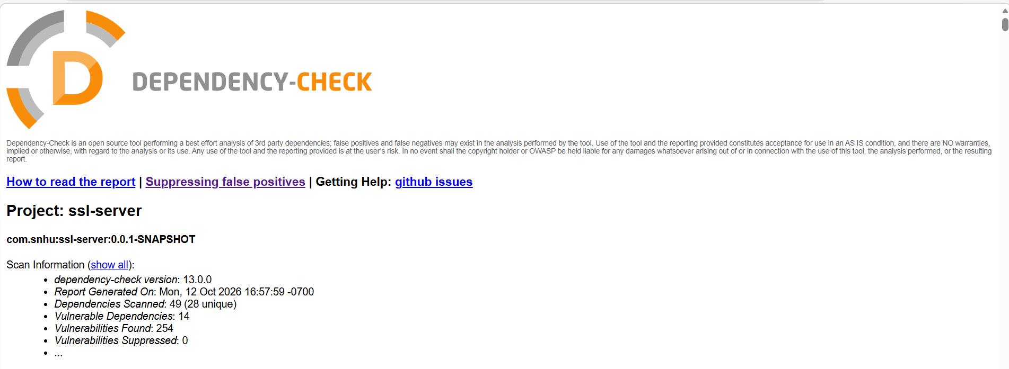
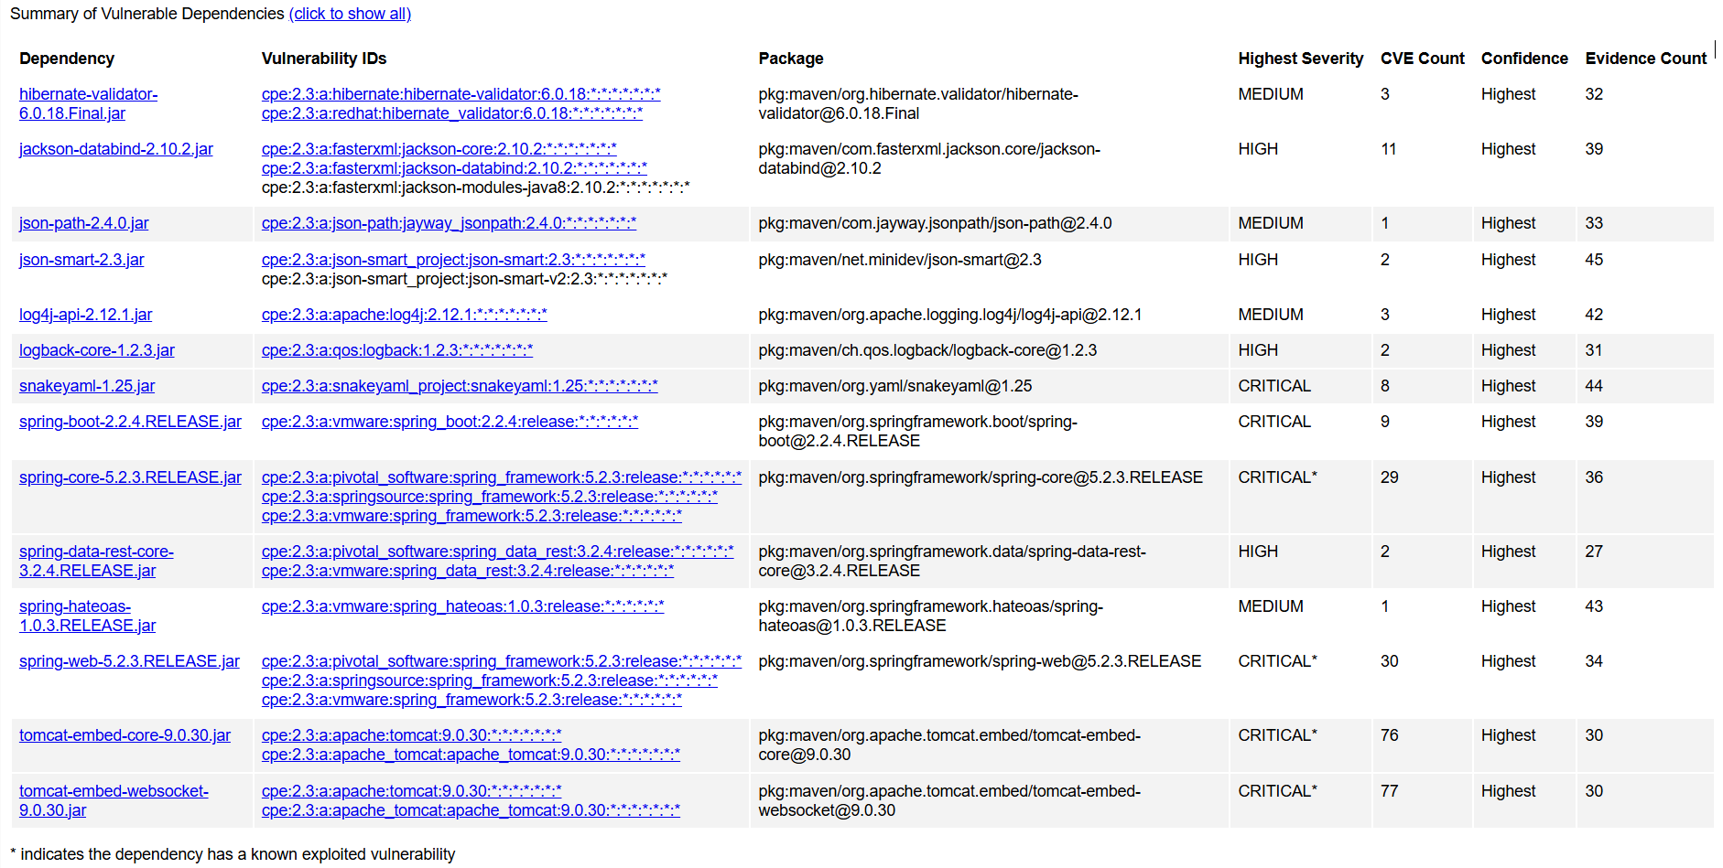

Functional Testing
Insert a screenshot below of the refactored code executed without errors.

The application was executed successfully after refactoring. No syntax or runtime errors occurred. The HTTPS configuration and SHA-256 hashing function operated as expected.

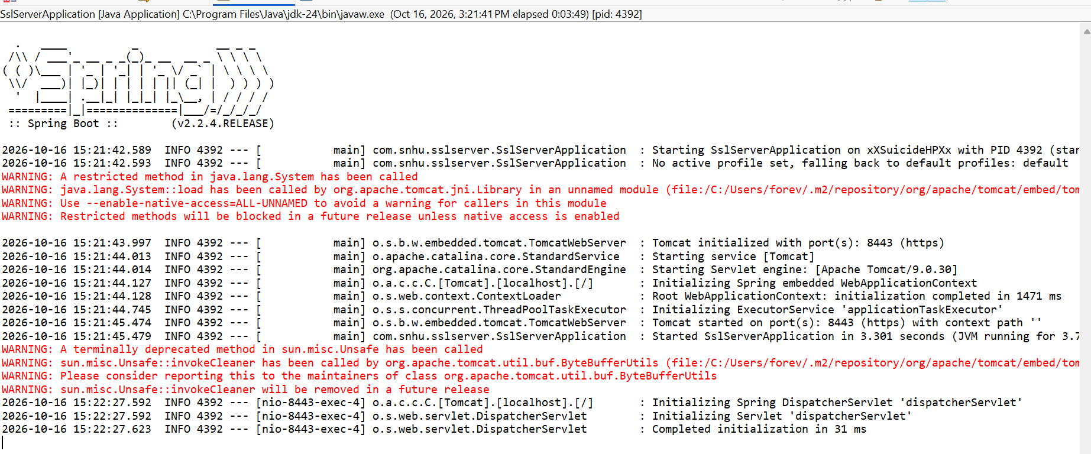
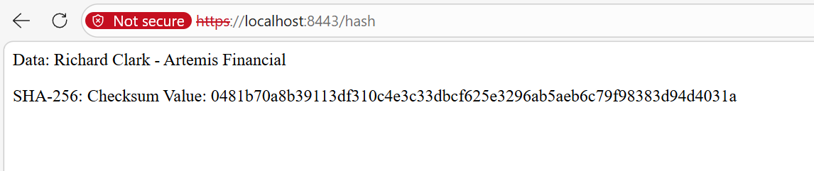

Summary
Although the application does not accept raw user input through forms or interfaces, the hashing endpoint does process user-provided data. This input is immediately converted into a secure SHA-256 digest, ensuring that the application handles only safe, fixed-format representations rather than raw or potentially unsafe data. This directly supports Input Validation and Secure Input and Representations.
To address the Secure API Interactions, I used OWASP Dependency-Check to identify vulnerabilities in the third-party libraries that support the application’s API and web functionality. This ensured that the refactoring process did not introduce new insecure dependencies and allowed me to document existing vulnerabilities for future mitigation.
In the Cryptography section of the diagram, I implemented a SHA-256 hashing function to protect data integrity and prevent tampering. I also configured HTTPS/TLS using a self-signed certificate, ensuring that all communication between the client and server is encrypted rather than transmitted in plaintext. Enforcing HTTPS on port 8443 prevents interception and strengthens the confidentiality of client-server interactions.
The refactored code starts and runs without runtime errors, demonstrating stable and secure interactions between the client and server. The successful execution screenshots confirm that the server handles operations cleanly and does not expose sensitive information through failures.
I addressed Code Error and Code Quality by manually reviewing the refactored code for syntactical and logical issues and ensuring that the hashing logic uses a secure, modern algorithm. The clean execution of the application demonstrates improved code quality and adherence to secure coding practices.
Finally, Encapsulation and Secure Data Structures are supported by keeping hashing and certificate handling within well-defined methods that do not expose internal details to the client. The SHA-256 hashing function produces a secure, consistent output, preventing raw or unsafe data from moving through the system. The SSL configuration is encapsulated within the server’s properties rather than being influenced by user input, reducing the risk of accidental exposure or manipulation.
I added security to the application in multiple layers. First, I implemented Transport Layer Security (TLS) by enabling HTTPS and configuring a secure keystore, ensuring all communication between the client and server is encrypted. To protect data integrity, I added a SHA-256 hashing function that verifies authenticity and prevents tampering. I strengthened configuration security by updating the application.properties file to enforce secure defaults and eliminate insecure settings. I also incorporated a dependency security layer by running OWASP Dependency-Check to identify vulnerable third-party libraries that could affect the application’s API and web functionality. Finally, I performed a manual code review to verify syntactical correctness, logical accuracy, and adherence to secure coding practices, ensuring the refactored application runs cleanly and securely.

Industry Standard Best Practices

I applied several industry standard best practices throughout the refactoring process to maintain and strengthen the application’s existing security. One of the primary practices was implementing secure cryptographic methods, such as using SHA-256 for hashing, which is widely recognized as a reliable and modern algorithm for protecting data integrity. I also enforced HTTPS/TLS using a properly configured keystore, ensuring that all client-server communication is encrypted according to industry standards for secure transport. Additionally, I used OWASP Dependency-Check to identify vulnerabilities in third-party libraries, which aligns with best practices for managing external dependencies and reducing exposure to known security risks. Manual code review further supported secure coding practices by ensuring that the application runs without syntax errors, logic flaws, or insecure patterns.
Applying industry standard best practices provides significant value to the company’s overall well-being. These practices reduce the likelihood of security breaches, data tampering, and unauthorized access, all of which can lead to financial loss, reputational damage, and operational disruption. By following secure coding guidelines, the company strengthens the reliability and trustworthiness of its software, protects sensitive information, and ensures compliance with regulatory expectations. Consistently applying these best practices also creates a more maintainable and resilient codebase, making future updates safer and easier to implement. In the long term, this contributes to a stronger security posture and supports the company’s ability to deliver secure, high-quality software to its users.

Resources:

Manico, J., & Detlefsen, A. (2014). Iron-Clad Java: Building Secure Web Applications. McGraw Hill Computing

Southern New Hampshire University. (2026). CS 305 Vulnerability Assessment Process Flow Diagram [PDF]. https://learn.snhu.edu/content/enforced/2377304-CS-305-12569.202681-1/course_documents/CS%20305%20Vulnerability%20Assessment%20Process%20Flow%20Diagram.pdf

